**A NOVEL SPECTRAL EFFICIENT OFDM SCHEME FOR VISIBLE LIGHT COMMUNICATIONS**

Submitted in partial fulfillment of the requirements

of the degree of

(Bachelor of Technology)

by

|  |  |
| --- | --- |
| **K. Susmitha** | **164227** |
| **P. Dilip Teja** | **164248** |
| **P. Maneendra** | **164235** |

Supervisor:

### Dr.V.V.Mani

Associate Professor



DEPARTMENT OF ELECTRONICS AND COMMUNICATION ENGINEERING

NATIONAL INSTITUTE OF TECHNOLOGY, WARANGAL

2019-2020

**ABSTRACT**

The number of users of various mobile devices like smart phones has increased which

lead to an higher data access over the wireless networks. Due to this there is a possibility that

the existing RF spectrum can get exhausted. So the Visible light communications (VLC) has

become the prominating alternative to the existing one in which the data can be sent by light intensity modulation which can be detected by the photodetector. It has several

advantages over the conventional one like high data rates, a huge unlicensed bandwidth as it is visible light tolerance to electromagnetic interference and so on. Moreover OFDM can be employed to the VLC to reduce the effects of fading and ISI. Since it is the intensity of light that gets modulated in the optical case transmitted symbols must be unipolar and real valued. There are a lot of techniques to get this. Most predominantly Hermitian symmetry is employed to get the real signals which results in the spectral efficiency loss. And also there is loss in energy efficiency due to the added dc bias to get the unipolar signals. So there is a need to improve the spectral efficiency and energy economy of the conventional scheme while maintaining the other performance parameters.

So we propose and implement a novel ofdm modulation scheme which can be

employed to the visible light communications in which the information bits decide the indices of the sub carriers that are to be activated with the left remaining inactive and the data is transmitted through the indices of these active subcarriers along with the M-ary signal constellations. The results show that with the increase in the number of active carriers the spectral efficiency can be improved and also with a better bit error rate performance. There is a compromise or equal exchange between the efficiency of the usage of the spectrum and the performance. The energy efficiency is improved because of the inactive subcarriers. In the future work, trying to improve the performance at high spectral efficiencies and also to reduce the PAPR at the transmitter. And also to implement a low complexity receiver to achieve a low cost vlc system with better performance.

## CONTENTS

**Abstract 2**

1. **Introduction…………………………………………………………………………4**
2. **Review of Literature………………………………………………………………..6**
3. **Report on present Investigation…………………………………………………...8**
   1. **Orthogonal Frequency Division Multiplexing (OFDM) ...…………………..8**
   2. **Index Modulation (IM)…………………………………………………………9**
      1. Introduction…………………………………............................................9
      2. Index Modulation for OFDM (OFDM-IM)………………………………9

3.2.2.1. Transmitter………………………………………………………9

3.2.2.2. Detector…………………………………………………………10

3.2.2.3. Spectral Efficiencies of OFDM and OFDM with index modulation………………………………………………………………..11

3.2.2.4. Index Selection Procedures……………………………………..11

* + 1. Enhanced OFDM-SIM………..………………………………………….12
  1. **Index Modulation for OFDM-VLC…………………………..……….……….13**

1. **Results and Discussion………………………………………………….…………15**
   1. **Comparison of OFDM-IM with the conventional OFDM……………….…..15**
   2. **Comparison of OFDM and OFDM with index modulation for VLC………..16**
2. **Conclusions………………………………………………………………..………...18**
3. **Literature Cited…………………………………………………………….………19**

**Chapter 1**

**Introduction**

In the present world of gadgets, machines and smart devices, there is need of continuous communication and internet access by the people. And this is the era of IOT which involves the connection of various devices through the internet like home appliances, television, refrigerator etc. Vehicular communication is also an emerging technology which involves vehicle to vehicle communication, vehicle to devices like smart phones and electronic gadgets communication etc. which leads to the smart cities. So the demand for the wireless communications has increased to an extent that the currently existing infrastructure can’t provide enough resources for the wireless communication.

Among the various alternative technologies to the RF, Visible light communications has a great potential. It has become interesting to the researchers due to the high frequency spectrum (430THz to 790THz) of the visible light which can provide both illumination and communication. These high frequencies can provide high speed optical communication. The low cost light emitting diodes which have been widely using these days for lighting can provide communication with high switching speeds is also an interesting aspect for the researchers which can lead a way to the new innovations.

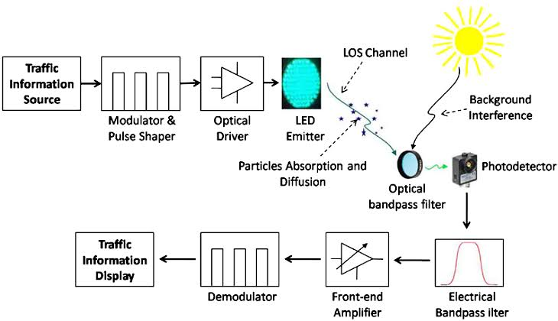

However there are many obstacles which prevent the VLC technology from being commercialized. Interference, uplink, dimming control and flickering are some of these.

Various modulation schemes can be employed with the optical communications such as M-PAM, BPSK, QPSK, M-QAM and so on depending on the application .One of the widely used multicarrier modulation scheme is OFDM which uses multiple narrow band orthogonal carriers to provide high speed with reduced intersymbol interference and reduced multipath fading effects with simple equalizers in the wireless channels. Since the OFDM scheme has to be modified for optical communications , there is loss in spectral efficiency . Since the visible light communications is mainly used for indoor applications and IOT applications, it is required to transmit the data with higher speed with optimized usage of spectrum and bandwidth. So here comes the need to improve the system performance with effective usage of the available bandwidth and the spectrum.

**Chapter II**

**Review of Literature**

OFDM is the widely used multicarrier modulation scheme used in RF [1]. Due to its

inherent advantages VLC also adapts OFDM. But due to the intensity modulation of light in

VLC , the OFDM symbols to be transmitted should be real and unipolar [9]. Researchers paved

their way in order to develop the efficient techniques to obtain the real and unipolar signals. One

of the methods to convert the signal into real is that the inputs to the IFFT block should satisfy Hermitian symmetry [9] in which first half carriers are used to transmit the useful data and the remaining half to transmit the conjugates of the first half. Thus it reduces the spectral efficiency to half. In order to increase the spectral density of the information , instead of imposing the Hermitian Symmetry, various other transforms instead of IFFT and FFT [12] can be used to obtain the real valued signals and so on . In order to convert bipolar signals to unipolar, several schemes are introduced . There is a technique in which proper DC bias is added to the signals followed by clipping of negative part to get positive signals which results in loss of energy efficiency due to the added bias. ACO-OFDM [13] in which data is transmitted only on odd or even subcarriers inorder to reduce the noise added due to clipping which also results in spectral efficiency loss due to the usage of only half the subcarriers. Several hybrid schemes are under investigation to improve the performance like ADO-OFDM and its hybrid technique . Each method has its own merits and drawbacks.

One of recently emerging technologies in the wireless networks to meet the 5G requirements is Index Modulation (IM) [1] in which the the indices of the carrier blocks of the respective communication system are also used to transmit the data along with the M-ary constellations. The building blocks can be timeslots, antenna, frequency carrier etc. Spatial Modulation (SM) [10] can be employed with MIMO system in which the building blocks for the IM are the antennas. The building blocks can be the subcarriers in case of OFDM system (OFDM-IM). OFDM-IM has various advantages over the classical OFDM scheme. The spectral efficiency of the conventional scheme can be increased by adjusting the number of carriers that are active and adjusting the modulation order. Several variants of OFDM-IM have been proposed in order to improve the performance and also to decrease the complexity of the receiver. Another variation of index modulation for OFDM [16] is proposed in which on-off keying fashion is employed to transmit one bit of data on each subcarrier and the activated subcarriers are modulated by the conventional modulation schemes. This method can impose high bit error rate. So Enhanced SIM (ESIM) [17] in which subcarrier bits are used to convey the on-off keying bits. Another OFDM-IM scheme is proposed in which the total carriers are made into sub groups, and in each sub group the modulated data is transmitted by the activated subcarriers. Several generalized OFDM-IM schemes are also proposed in which the number of carriers that are activated in each sub group is different. These generalized schemes can significantly increase the efficiency. Recently Dual mode- IM aided OFDM has been under investigation in which all the subcarriers are activated and each subblock is further divided into two blocks modulated by two different modulation orders. Investigations have also been done in order to make the system feasible by reducing the complexity of the Maximum likely hood or log likelyhood detector for OFDM with index modulation.

A better decision rule has been proposed in [8].

.

**Chapter III**

**Report on the present investigation**

**3.1 Orthogonal Frequency Division Multiplexing (OFDM)**

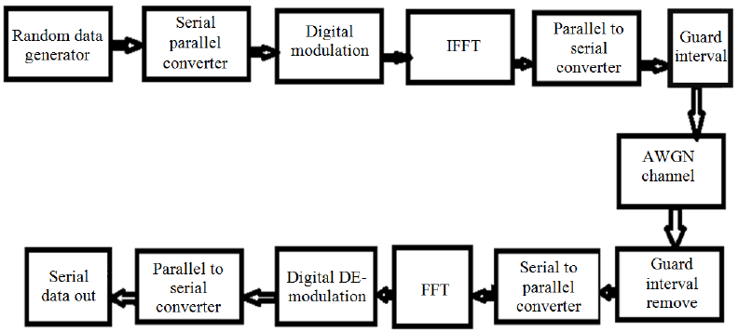

OFDM is a multicarrier modulation scheme which uses a number of sub carriers. It doesn’t contain individual bandlimited subcarriers but are overlapped to improve the efficiency of bandwidth utilization by dividing the spectrum into N orthogonal narrowband subchannels. FFT and IFFT are used to produce these multiple orthogonal subcarriers effectively. After IFFT at the transmitter, a guard band called cyclic prefix is inserted in order to reduce the intersymbol interference. At the detector, this cyclic prefix is eliminated and the parallelised data is subjected to FFT and then demapped .Thus the data rate is widely increased without causing ISI and reduced multichannel fading effects.

**3.2.Index modulation (IM)**

**3.2.1.Introduction**

Index modulation is a technique which can be employed with any modulation scheme like QPSK, BPSK, M-QAM etc. Unlike the traditional amplitude or phase modulation , in IM, the indices of the blocks of respective communication system also transmits data.( Frequency domain, space domain, space-time domain etc). The two variants of Index modulation, Spatial Modulation (SM) where indices of the antennas carry information and subcarrier index modulation are the two interesting fields for researchers.

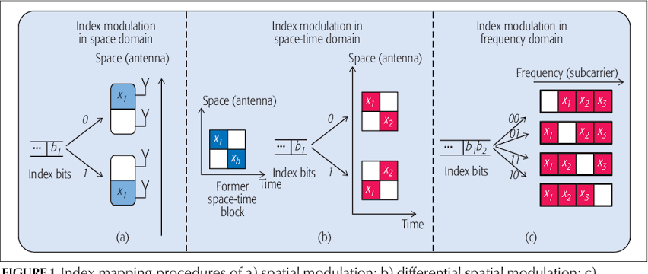

**3.2.2.Index modulation for OFDM (OFDM-IM)**

**3.2.2.1.Transmitter**

In OFDM-IM, according the data , the bits are divided and the first part of the information bits are used to decide the active subcarriers and the second part of the bits are modulated by these active subcarriers.

Consider the OFDM system with N subcarriers in which the total number of bits is m in each OFDM block. These total transmitted bits and the total number of carriers are divided into sub blocks which are g in number with p bits and n carriers in each sub block where m=p*g and N=n*g. Unlike the conventional OFDM, only k subcarriers out of n in each sub block are activated. The first p1 bits of the p bits are used to select the indices of the active subcarriers and these active subcarriers are modulated by the next p2 bits. Thus p = p1+p2 is the total number of bits transmitted in each sub block.

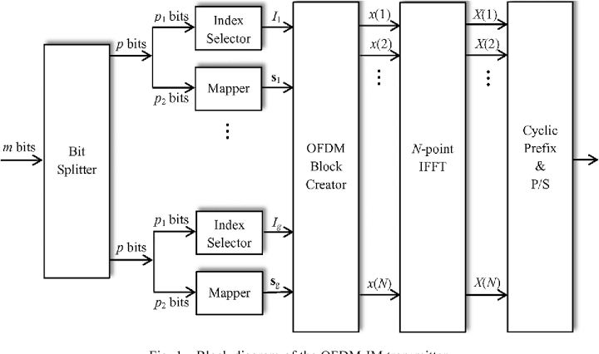

So the number of transmitted bits in each OFDM block is m = g(p1+p2).

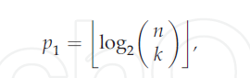

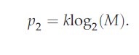

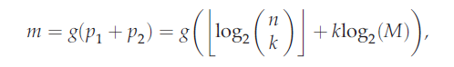

Where M is the order of modulation.

subcarriers and the second part of the bits are modulated by these active subcar These bits of subblocks are combined and are subjected to IFFT and the cyclic prefix is added and transmitted as in conventional OFDM scheme.

**3.2.2.2. Detector**

The receiver can be ML detector or LLR detector.

**ML detector:**

The Maximum Likely hood detector is the detector which considers all the possible received symbols and the constellation mappings . But the ML detector is complex to implement for higher orders of modulation and with more number of subcarriers ( n and k) because of the increase in the number of possible realizations.

**LLR detector:**

In order to make the detector simple , the log-likelyhood (LLR) detector is proposed as an alternative to the ML detector. In LLR detector , the probabilities of the two possible cases of the symbols with the symbol being zero and non-zero are calculated. The log of the ratio between these probabilities which are aposterior is calculated in order to find the active and inactive subcarriers. The LLR value of the ith subcarrier is given by

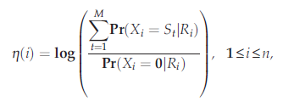

Active subcarriers will have a higher LLR values than the inactive and thus they are identified. As in the normal OFDM scheme , the symbols carried by these active carriers are demapped.

**3.2.2.3. Spectral efficiencies of OFDM and OFDM with index modulatio**

Thus the OFDM with index Modulation has a spectral efficiency of

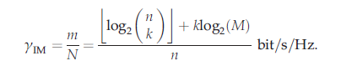

For the conventional OFDM, it is given as

C:\Users\My Pc\Pictures\Screenshots\Screenshot (275).png

This efficient usage of spectrum can be improved by the use of more number of active subcarriers. It provides an interesting trade off between the performance and the spectrum efficiency .And the energy consumed can also be reduced because of the subcarriers that are inactive. And also there is no need for null carriers or virtual subcarriers as in conventional OFDM due to the inactive subcarriers in between the active subcarriers.

**3.2.2.4. Index selection procedures:**

The index selection procedure can be implemented by two methods.

**1.Lookup table method:**

In this method, a table is to be developed at transmitter and the receive side. This table gives the indices of the active subcarriers depending on the p1 bits at the transmitter side and does the opposite operation on the receiver side. Although this is a simple method , it becomes complex for higher values of n and k due to the more number of possible combinations and increased size of the lookup tables and so the complexity of the system. So the following method can be used.

**2.Combinatorial method:**

The p1 bits are converted into the equivalent decimal integer and this algorithm provides one-to-one mapping of this number to the k combinations.

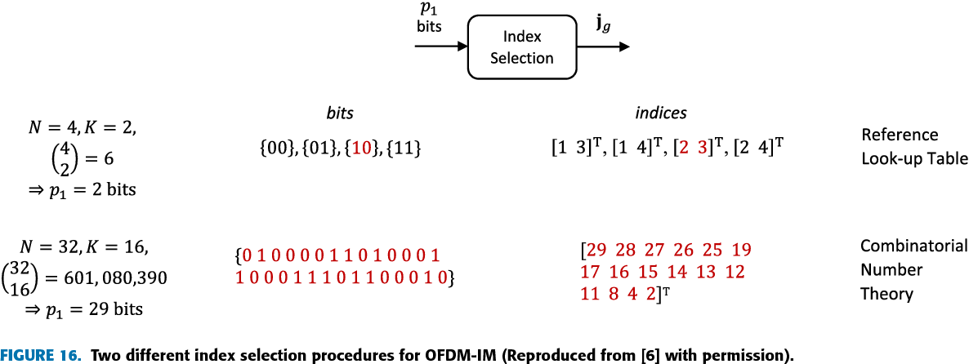

**3.2.3. Enhanced OFDM-SIM**

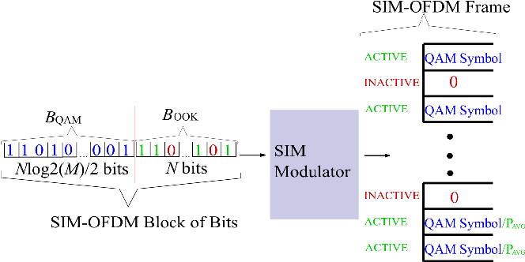

In applications where the complexity of the receiver matters, enhanced OFDM-SIM can be implemented. In this a pair of subcarriers is considered at a time and one in a pair is activated based

on the 1 or 0 in the bit sequence as in on-off keying scheme. At the receiver, since it is known that only one in a pair is activated, the absolute values of the symbols on the two subcarriers are compared to detect the active subcarrier . Thus reducing the complexity of the receiver. The only disadvantage of this OFDM scheme is reduced spectral efficiency because only half of the subcarriers can be activated at a time.

**3.3.Index Modulation for OFDM-VLC**

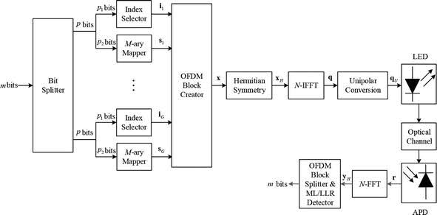

By making some modifications to the above discussed OFDM-IM it can be employed to the Visible light communications.

The index selection p1 bits and the M-ary modulated p2 bits are combined by the OFDM block creator .Before subjecting the signal to the IFFT block, Hermitian symmetry has to be imposed on the signal to convert it to real. It implies that only 1 to N/2-1 subcarriers carry the information that is useful and where the subcarriers from N/2+1 to N carry the conjugate flipped versions of the primary half

X(N-k) = X*(k) is the Hermitian Symmetry condition.

And now the IFFT is carried on this transformed signal and the resulting signal is still bipolar and so passed through the unipolar convertor. In this a proper bias is added to the signal. If excessive bias is added it results in loss of energy efficiency. So the power of the signal is calculated and a DC bias proportional to that power is added to get the unipolar signal.

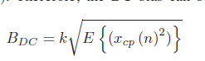

Where k is the factor of clipping. Clipping should be done to eliminate the negative peaks if any. And also a clipping noise gets added.

The resulting signal is transmitted by modulating the intensity of the light by the LED and passed through the optical channel. At the receiver photodetector is used to convert the light signal to an electrical signal and the same operations at the transmitter are performed inversely at the receiver like removing cyclic prefix, Fast Fourier Transform (FFT) and then the symbols are demapped using ML or LLR detector.

Thus the spectral efficiency of the DCO-OFDM with index modulation is given by

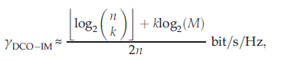

Thus there is an improvement in the spectral efficiency compared to the conventional DCO-OFDM when the number of activated subcarriers is increased.

**Chapter IV**

**Results and Discussion**

**4.1 Comparison of OFDM and OFDM with Index Modulation**

The total number of subcarriers taken is 128. And the symbols are modulated using QPSK.

For OFDM-IM the total sub carriers are divided into 16 sub blocks with 8 subcarriers in each sub-block. In each sub block 4 out of the 8 carriers are selected as active depending on the information bits where as in conventional OFDM all the sub carriers are active.

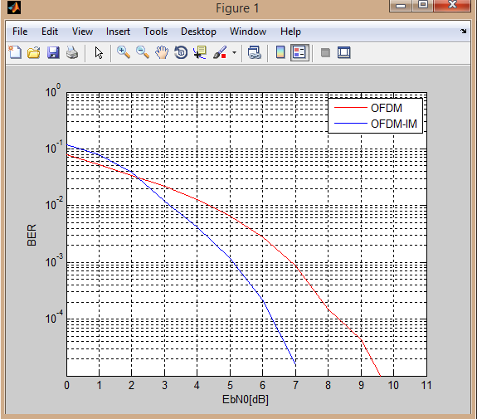

From the above plot it can be noticed that the OFDM-IM shows good results with improved spectral efficiency than the conventional OFDM.

**4.2 Comparison of OFDM and OFDM with index modulation for VLC**

The total number of carriers is taken as 128 i.e IFFT size. And the symbols are modulated using QPSK. Hermitian symmetry is applied and the added dc bias is 12dB. And the dc bias added is 12dB. . For OFDM-IM, the total number of subcarriers is divided into 16 subblocks and the number of carriers in each block is 4. And index selection procedure adapted is Combinatorial method.

**Case 1:**

2 out of the 4 carriers in each block are taken as active subcarriers.

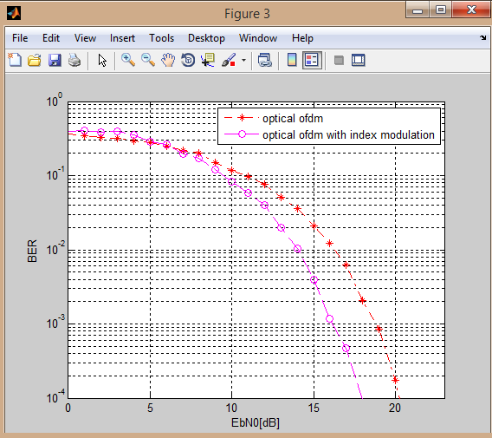

**Case 2:**

3 out of 4 subcarriers in each sub block are selected as active.

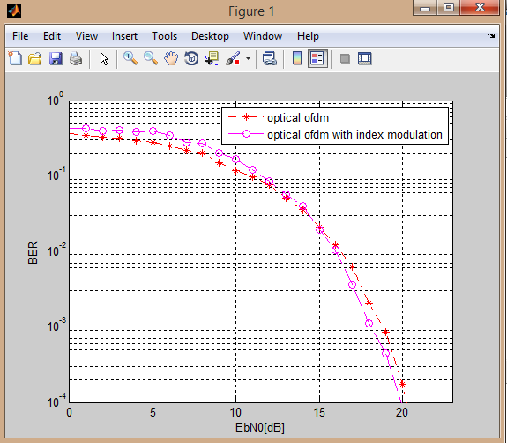

It can be seen that the index modulation shows better results than OFDM when half of the sub carriers are activated. When more number of sub carriers are activated to increase the spectral efficiency its BER performance is almost comparable with the OFDM that is conventionally used for VLC.

But in both the cases, index modulation scheme has better spectral efficiency than the conventional one.

**Chapter V**

**CONCLUSIONS**

Thus we proposed a novel technique , index modulation that can be employed with the optical OFDM. It is shown from the simulations that by adjusting the no.of active subcarriers in the system , an interesting compromise between the performance and the spectral efficiency can be observed. The performance has to be increased for higher spectral efficiencies using some hybrid OFDM-IM schemes.The PAPR Ratio at the transmitter has to be controlled by using PAPR reduction schemes . Thus the overall performance of the OFDM-VLC system can be improved by employing the index modulation techniques.

**Chapter VI**

**Literature Cited**

1. E. Basar, "Orthogonal Frequency Division Multiplexing with Index Modulation"IEEE Trans. Signal Processing , vol. 61, no. 22, pp. 5536-49, Nov. 2013.
2. M. Wen, "On the Achievable Rate of OFDM with Index Modulation", IEEE Trans. Signal Processing, vol. 64, no. 8, pp. 1919-32, Apr. 2016.
3. E. Basar, “Index Modulation Techniques for 5G wireless networks”, IEEE Communications Magazine ,Volume: 54 , Issue: 7July 2016 )
4. Xiang Cheng ;Meng Zhang; Miaowen Wen ; Liuqing Yang,”Index Moodulation for 5G:Striving to do more with less”, IEEE Wireless Communications, vol.25, 2018
5. S. Dissanayake, J. Armstrong, "Comparison of ACO-OFDM DCO-OFDM and ADO-OFDM in IM/DD systems", Techol,vol. 31, no. 7, pp. 1063-1072, Apr. 2013.
6. E. Basar; Erdal PanayırcıOptical OFDM with index modulation for visible light communications, IEEE International Workshop on Optical Wireless Communications (IWOW),2015
7. Ertugrul Basar, “Orthogonal Frequency Division Multiplexing With Index Modulation” IEEE TRANSACTIONS ON SIGNAL PROCESSING, VOL. 61, NO. 22, NOVEMBER 15, 2013
8. Qinwei He ; Anke Schmeink ,”A better decision rule for OFDM with subcarrier index modulation,WSA 2017; 21th International ITG Workshop on Smart Antennas
9. Suseela Vappangi ; V. V. Mani,” Performance analysis of fast optical OFDM for VLC”, 2017 20th International Symposium on Wireless Personal Multimedia Communications (WPMC)
10. [Ertugrul Basar](https://ieeexplore.ieee.org/author/38666344600); [Miaowen Wen](https://ieeexplore.ieee.org/author/37720016500); [Raed Mesleh](https://ieeexplore.ieee.org/author/37296995700); [Marco Di Renzo](https://ieeexplore.ieee.org/author/37391990500); [Yue Xiao](https://ieeexplore.ieee.org/author/37556980400); Harald Haas;”Index modulation techniques for next generation wireless networks”; IEEE Access;vol.5,2017
11. J. Armstrong and B. J. Schmidt, “Comparison of asymmetrically clipped

optical ofdm and dc-biased optical ofdm in awgn,” *IEEE Communications Letters*, vol. 12, no. 5, 2008.

# [12] Ayad Atiyah Abdulkafi ; Mohamad Yusoff Alias ; Yaseein Soubhi Hussein,” Performance analysis of DCO-OFDM in VLC system”, 2015 IEEE 12th Malaysia International Conference on Communications (MICC),2015

 [13] S. Dissanayake, J. Armstrong, "Comparison of ACO-OFDM DCO-OFDM and ADO-OFDM in IM/DD Systems",J.Lightw Technol., vol. 31, no. 7, pp. 1063-1172, Apr. 2013.

[14]  D. Tsonev, H. Haas, "Avoiding spectral efficiency loss in unipolar OFDM for optical wireless communication",Proc. IEEE ICC, pp. 3336-3341, Jun. 2014.

[15]  T. Mao, R. Jiang, R. Bai, "Optical dual-mode index modulation aided OFDM for visible light communications",Optical communication, vol. 391, pp. 37-41, May 2017.

[16] Harald Haas; “Subcarrier Index Modulation OFDM”; IEEE 20th International Symposium on Personal, Indoor and Mobile Radio Communications,2009

[17] Dobroslav Tsonev ; Sinan Sinanovic; Harald Haas;”Enhanced Subcarrier Index Modulation (SIM) OFDM”, **:**2011 IEEE GLOBECOM Workshops (GC Wkshps)